Student’s name | …………………………………………………….…… | Grade | 2
Subject | Computer | Week No. | 9
Lesson Title | Edit Video | Unit
Worksheet No. ( 9 ) (Answer)

Question A:

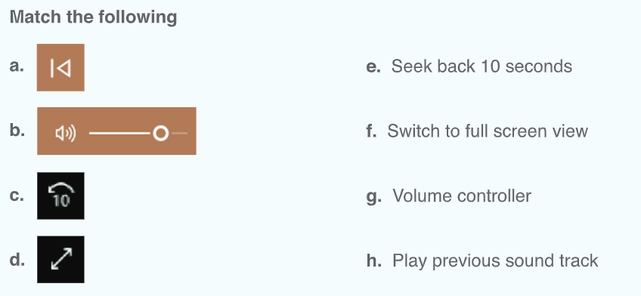
Good Luck

